COURSE OBJECTIVES AND OUTCOMES
Course Objectives
- To get an overview of the various supervised machine learning techniques
- To understand and evaluate the various unsupervised machine learning techniques
- To demonstrate single layer and multilayer feed forward neural networks
- To understand training, building and evaluating a model
- To demonstrate a real-world case study
Course Outcomes

CO | After completion of the course, the student should be able to
CO-1 | Illustrate Supervised Machine Learning algorithms
CO-2 | Develop Unsupervised Machine Learning algorithms
CO-3 | Implement single layer and feed forward neural networks
CO-4 | Build and evaluate a model using machine learning techniques
CO-5 | Perform experiments in Machine Learning using real-world data

INDEX

Week | Name of the Experiment | Page No. | Date | Signature
Pre | Data Exploration and Visualization using Pandas
1 | Naïve Bayes Classifier and k-Nearest Neighbor (k-NN)
2 | Decision Trees – ID3 and CART
3 | Linear Regression and Logistic Regression
4 | Support Vector Machines – Linear and Non-Linear
5 | Unsupervised k-Means Clustering Algorithm
6 | EM Algorithm vs k-Means Clustering
7 | Model Training: Holdout, K-Fold Cross Validation and Bootstrap Sampling
8 | Evaluating Model Performance (Lower Back Pain Symptoms Dataset)
9 | Random Forest Learning Algorithm
10 | AdaBoost and XGBoost Algorithms
11 | Single Layer Perceptron and Multilayer Perceptron
12–13 | Real-World Case Study: Amazon Food Reviews

PRELIMINARY: Data Exploration and Visualization using Pandas
Experiment No: 1 Date: / /

AIM
To read a dataset and explore it using basic pandas operations (head, tail, shape, columns, info, describe, missing values) and to plot a scatter graph.

SOFTWARE REQUIRED
Python 3.x, Jupyter Notebook / Google Colab / Anaconda, NumPy, pandas, scikit-learn, matplotlib, seaborn.

ALGORITHM
- Import the required libraries (pandas, matplotlib).
- Read the dataset from the CSV file.
- Display the first 5 rows (head) and the last 5 rows (tail).
- Display the shape (rows, columns) and the column names of the dataset.
- Display the data types and non-null counts using info().
- Display the statistical summary using describe().
- Check for missing values using isnull().sum().
- Plot a scatter graph between two numeric columns.

Data exploration and scatter plot
import pandas as pd
import matplotlib.pyplot as plt
from sklearn.datasets import load_iris

d=load_iris()
df=pd.DataFrame(d.data,columns=d.feature_names)
df["species"]=[d.target_names[i] for i in d.target]

print("Dataset Shape:",df.shape)
print("\nFirst 5 Rows:")
print(df.head())
print("\nSummary Statistics:")
print(df.describe())
print("\nSpecies Count:")
print(df["species"].value_counts())

for s in d.target_names:
x=df[df["species"]==s]
plt.scatter(x["sepal length (cm)"],x["sepal width (cm)"],label=s)

plt.xlabel("Sepal Length (cm)")
plt.ylabel("Sepal Width (cm)")
plt.title("Iris Dataset - Scatter Plot")
plt.legend()
plt.grid(True)
plt.show()

OUTPUT
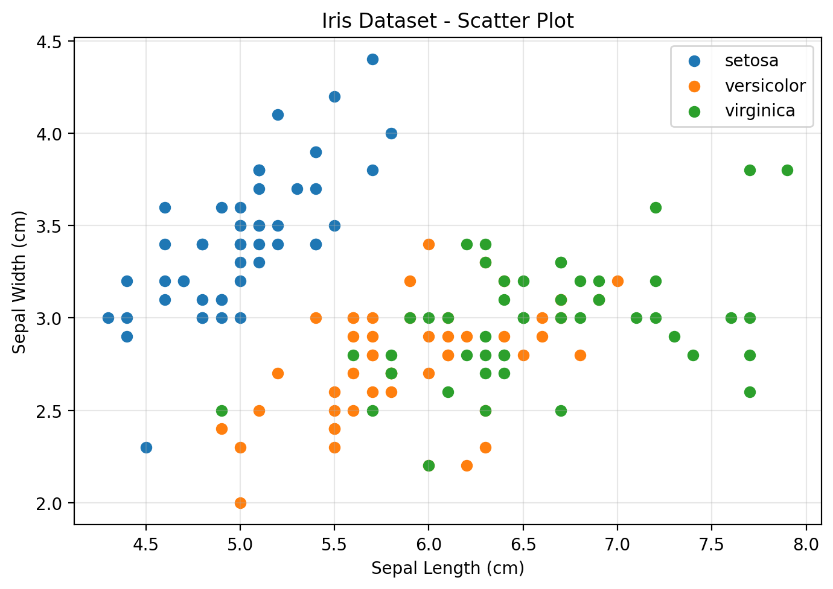

VIVA QUESTIONS
Q1. What is the difference between head() and tail()?
head() displays the first few rows of a dataset, while tail() displays the last few rows. By default, both display 5 rows.
Q2. How do you detect and handle missing values in pandas?
Missing values can be detected using functions such as isnull() or isna(). They can be handled by removing the missing rows/columns or by replacing the missing values with suitable values such as the mean, median, or mode.
Q3. What does describe() report?
describe() provides a statistical summary of numerical data, including count, mean, standard deviation, minimum, 25th percentile, median (50th percentile), 75th percentile, and maximum.

Date: Faculty Signature:

WEEK 1: Naïve Bayes Classifier and k-Nearest Neighbor (k-NN)
Experiment No: 2 Date: / /

AIM
To implement the k-Nearest Neighbor (k-NN) and Naïve Bayes classifiers and evaluate their accuracy.

SOFTWARE REQUIRED
Python 3.x, Jupyter Notebook / Google Colab / Anaconda, NumPy, pandas, scikit-learn, matplotlib, seaborn.

ALGORITHM
- k-NN: load the dataset and split it into training and testing sets.
- k-NN: choose the value of k and compute the distance from the test sample to every training sample.
- k-NN: select the k nearest neighbours and assign the majority class among them.
- Naïve Bayes: compute the prior probability of every class from the training data.
- Naïve Bayes: compute the likelihood of every feature for each class (assuming features are independent).
- Naïve Bayes: predict the class with the highest posterior probability.
- Evaluate both models using accuracy and confusion matrix.

FORMULAS
k-NN Euclidean distance:

Naïve Bayes posterior:
𝑑(𝑥, 𝑦) =

𝑛
𝑖 𝑖
𝑖=1
2
𝑛
∑ (𝑥 − 𝑦 )

𝑃(𝐶 | 𝑥) ∝ 𝑃(𝐶)∏ 𝑃(𝑥 | 𝐶)
𝑖=1 𝑖
Gaussian likelihood:
1 (𝑥 − µ)
( 2 )

𝑃(𝑥 | 𝐶) =
𝑖
𝑒𝑥𝑝 − 𝑖

2σ
2
2πσ
2

PROGRAM
- k-Nearest Neighbor classifier
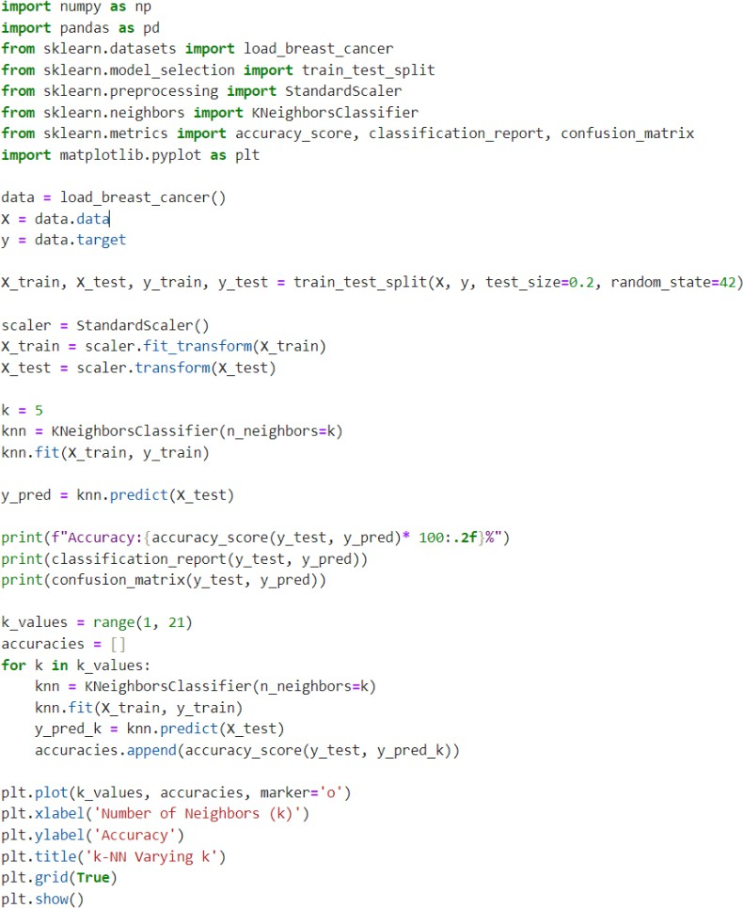

- Naïve Bayes classifier
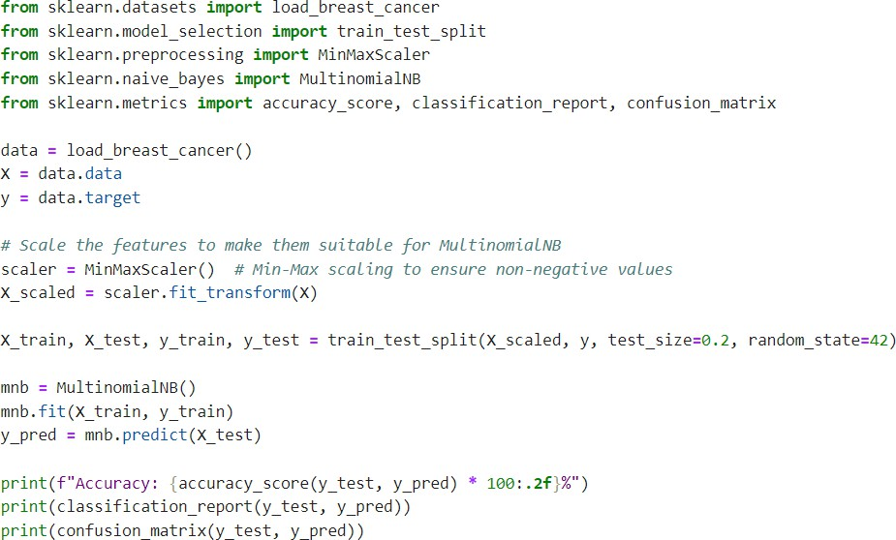

OUTPUT
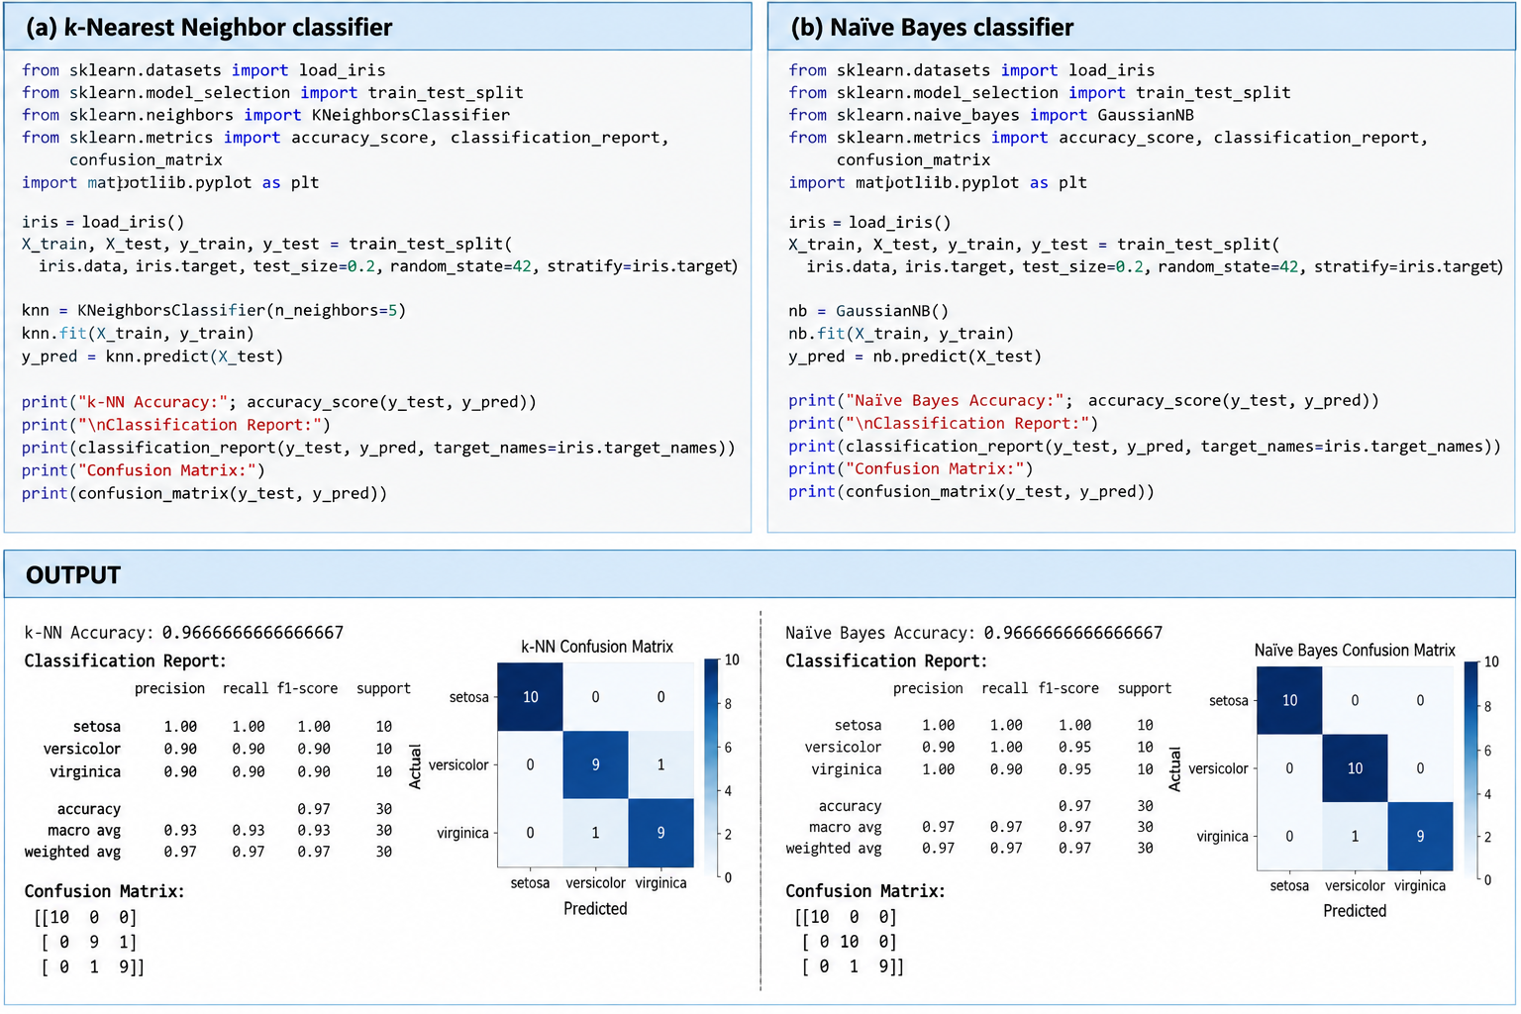

VIVA QUESTIONS

Q1. Why is the Naïve Bayes classifier called “naïve”?
It is called “naïve” because it assumes that all features are independent of each other given the class. This assumption is often not completely true in real-world data, but it makes the algorithm simple and fast.

Q2. How does the value of k affect k-NN?
- Small k: The model is sensitive to noise and may overfit.
- Large k: The model becomes smoother and less sensitive to noise but may underfit.
- A suitable value of k provides a good balance between overfitting and underfitting.

Q3. Why is feature scaling important for k-NN?
k-NN uses distance to determine the nearest neighbors. If features have different scales, a feature with larger numerical values can dominate the distance calculation. Feature scaling puts features on a similar scale, ensuring that each feature contributes appropriately to the distance.

Date: Faculty Signature:

WEEK 2: Decision Trees – ID3 and CART
Experiment No: 3 Date: / /

AIM
To implement Decision Trees – ID3 and CART using Python.

SOFTWARE REQUIRED
Python 3.x, Jupyter Notebook / Google Colab / Anaconda, NumPy, pandas, scikit-learn, matplotlib, seaborn.

ALGORITHM
  - ID3: import the required libraries and load the Iris dataset.
  - ID3: split the dataset into training and testing sets.
  - ID3: create a Decision Tree model using entropy as the criterion.
  - ID3: train the model on the training data and predict the output for the test data.
  - ID3: evaluate using accuracy, confusion matrix and classification report; visualise the decision tree.
  - CART: load and split the Iris dataset.
  - CART: create a Decision Tree model using gini as the criterion and train it on the training data.
  - CART: predict the output for the test data, evaluate using accuracy, confusion matrix and classification report; visualise the decision tree.

FORMULAS
Entropy:
𝑐
𝐻(𝑆) = − ∑ 𝑝 𝑙𝑜𝑔₂𝑝

Information Gain:
𝑖
𝑖=1

𝐺𝑎𝑖𝑛(𝑆, 𝐴) = 𝐻(𝑆) − ∑
𝑖

|𝑆 |
𝑣 𝐻(𝑆 )

Gini Index:
𝑣 ∈ 𝑉𝑎𝑙𝑢𝑒𝑠(𝐴)

𝑐
2
|𝑆| 𝑣

𝐺𝑖𝑛𝑖(𝑆) = 1 −
∑ 𝑝
𝑖

𝑖=1

PROGRAM
- ID3 (criterion = entropy)
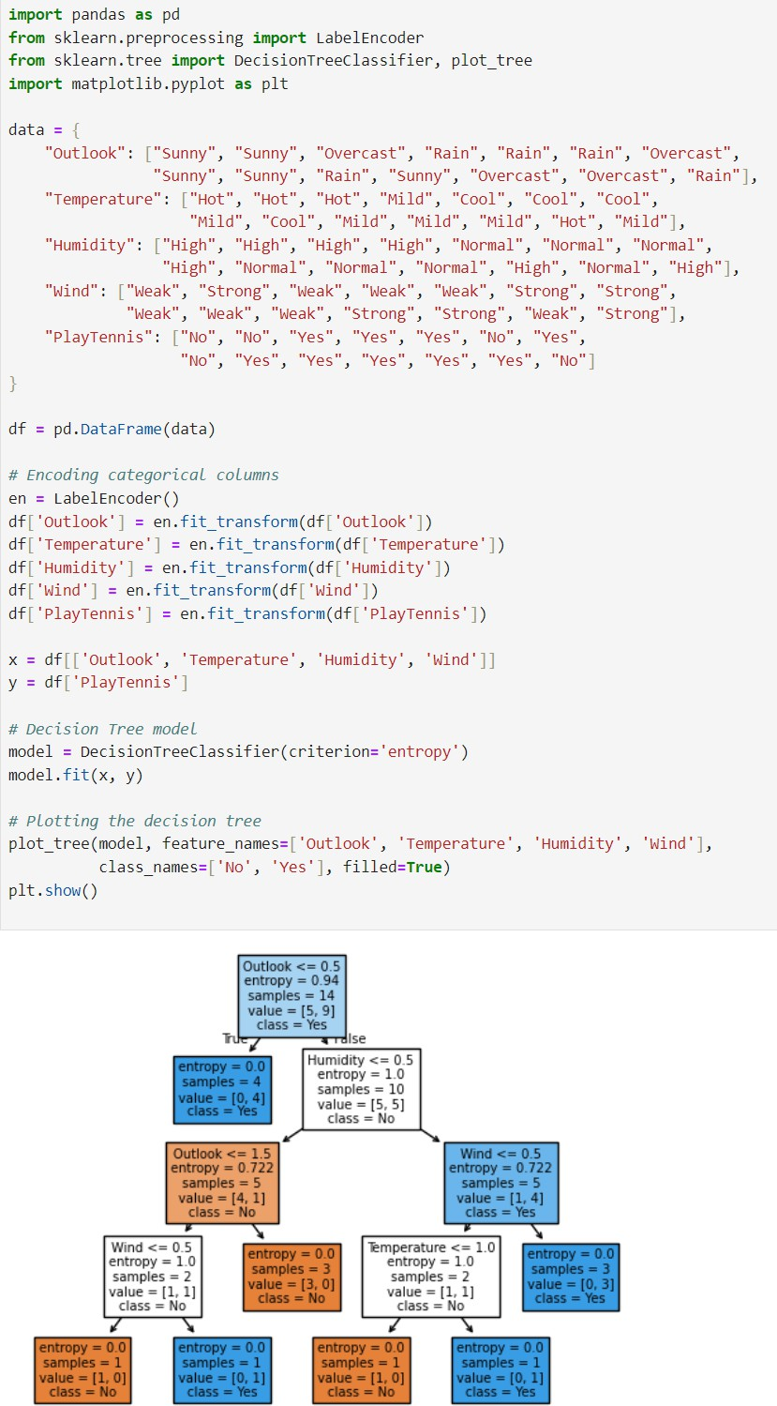

- CART (criterion = gini)
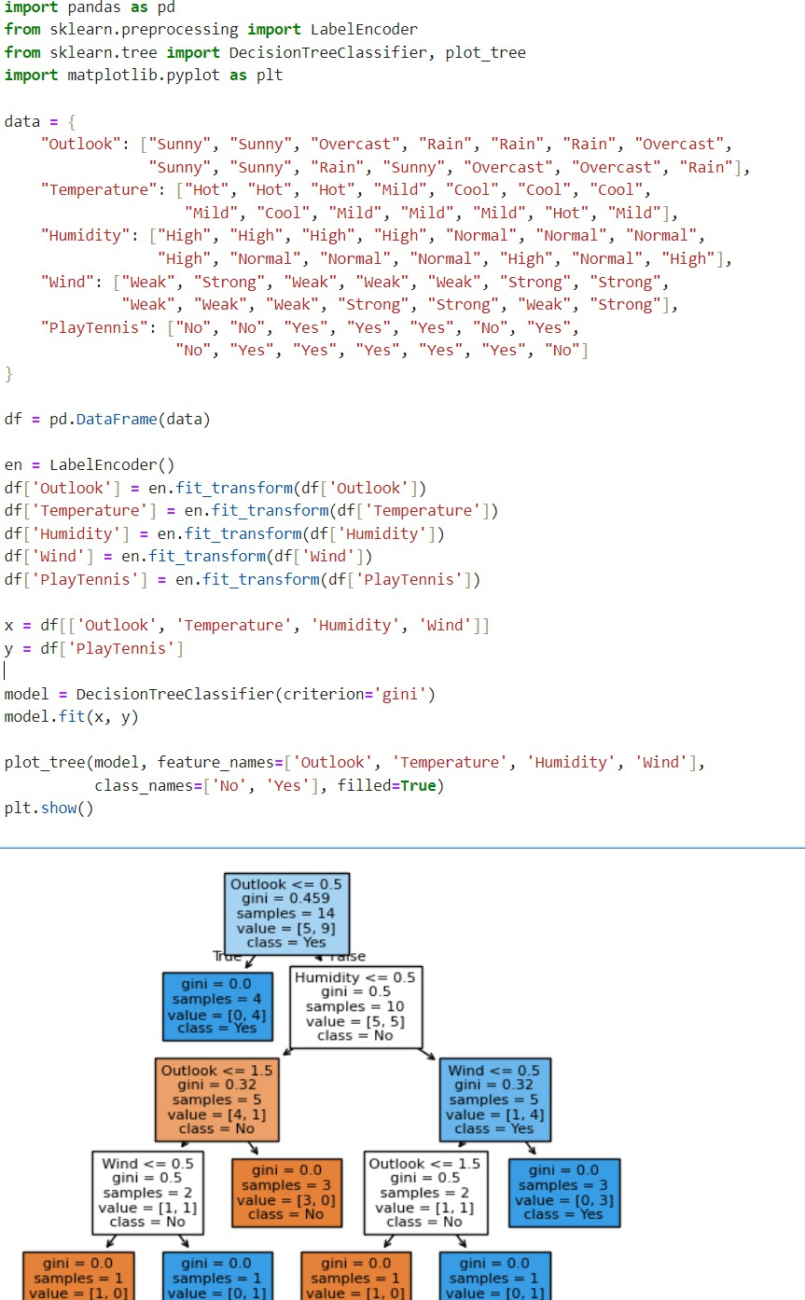

OUTPUT

VIVA QUESTIONS
Q1. What is entropy and information gain?
Entropy measures the impurity or uncertainty in a dataset. Higher entropy means the data is more mixed, while lower entropy means the data is more pure.
Information Gain measures how much uncertainty is reduced after splitting the data based on a particular feature. A decision tree generally selects the feature with the highest information gain for splitting.
Q2. Differentiate between ID3 and CART.
ID3 | CART
Uses Information Gain | Uses Gini Index for classification
Produces multi-way splits | Produces binary splits
Mainly used for classification | Used for classification and regression
Can handle categorical features | Can handle numerical and categorical features
Developed by Ross Quinlan | Developed by Breiman and others
Q3. How can overfitting in decision trees be reduced?
Overfitting can be reduced by:
- Limiting the maximum depth of the tree.
- Setting a minimum number of samples required for splitting.
- Setting a minimum number of samples in a leaf.
- Pruning unnecessary branches.
- Using ensemble methods such as Random Forest.
- Using cross-validation to select suitable tree parameters.

Date: Faculty Signature:

WEEK 3: Linear Regression and Logistic Regression
Experiment No: 4 Date: / /

AIM
To implement Linear Regression (single and multiple features) and Logistic Regression (single and multiple features) on small real-life problems.

SOFTWARE REQUIRED
Python 3.x, Jupyter Notebook / Google Colab / Anaconda, NumPy, pandas, scikit-learn, matplotlib, seaborn.

ALGORITHM
  - Create the dataset and, where required, split it into training and testing sets.
  - Linear Regression: fit the line (or plane) that minimises the mean squared error and print the slope(s) and intercept.
  - Predict the target for new input and evaluate using the Mean Squared Error (MSE).
  - Logistic Regression: fit the model to the binary target using the sigmoid function.
  - Predict the class and the class probability for new input.
  - Evaluate using the classification report and confusion matrix (plot with seaborn heatmap).

FORMULAS
Simple linear regression:

Multiple linear regression: Mean Squared Error:
𝑦 = 𝑚 𝑥 + 𝑐

ŷ = 𝑚 𝑥 + 𝑚 𝑥 + 𝑐
1 1 2 2

𝑛
(
2

Logistic (sigmoid) model:
𝑖
𝑀𝑆𝐸 = ¹ ∑
𝑖=1
𝑛
𝑦 − ŷ𝑖)

PROGRAM
𝑃(𝑦 = 1 | 𝑥) = ¹
1 +𝑒
−(𝑚 𝑥 + 𝑐)

Problem 1: House Price Prediction (Linear Regression)
Predict the price of a house (in Lakhs INR) based on its area in square feet.
- Create a dataset with Area = [500, 800, 1000, 1200, 1500, 1800, 2000] and Price = [25, 38, 48,
55, 68, 80, 90].
- Train a Linear Regression model.
- Predict the price of a house with an area of 1350 sq ft.
- Plot the data points and the regression line.

import numpy as np
import matplotlib.pyplot as plt
from sklearn.linear_model import LinearRegression

# Dataset
Area = np.array([500, 800, 1000, 1200, 1500, 1800, 2000]).reshape(-1, 1)
Price = np.array([25, 38, 48, 55, 68, 80, 90])

# Train the model
model = LinearRegression()
model.fit(Area, Price)

# Predict price for 1350 sq ft
area = np.array([[1350]])
predicted_price = model.predict(area)

print("Slope (m):", model.coef_[0])
print("Intercept (c):", model.intercept_)
print("Predicted price for 1350 sq ft:", predicted_price[0], "Lakhs")

# Plot
plt.scatter(Area, Price, color='blue', label='Actual Data')
plt.plot(Area, model.predict(Area), color='red', label='Regression Line')

plt.xlabel("Area (sq ft)")
plt.ylabel("Price (Lakhs INR)")
plt.title("House Price Prediction")
plt.legend()
plt.grid(True)
plt.show()

Problem 2: Car Mileage Prediction (Linear Regression – Multiple Features)
Predict fuel efficiency (KM per Liter) based on Engine Size (Liters) and Vehicle Weight (Tons).
- Construct a small dataset with 8–10 rows containing EngineSize, Weight and Mileage.
- Split the dataset (80% Train, 20% Test).
- Train a Linear Regression model and print the feature weights (m1, m2) and intercept (c).
- Calculate the Mean Squared Error (MSE) on the test set.
import numpy as np
from sklearn.model_selection import train_test_split
from sklearn.linear_model import LinearRegression
from sklearn.metrics import mean_squared_error

# Dataset
EngineSize = np.array([1.0, 1.2, 1.5, 1.8, 2.0, 2.2, 2.5, 2.8, 3.0, 3.5])
Weight = np.array([1.0, 1.1, 1.2, 1.4, 1.5, 1.6, 1.8, 1.9, 2.0, 2.2])
Mileage = np.array([22, 20, 18, 16, 15, 14, 12, 11, 10, 8])

# Combine features
X = np.column_stack((EngineSize, Weight))
y = Mileage

# Split dataset: 80% training, 20% testing
X_train, X_test, y_train, y_test = train_test_split(
X, y, test_size=0.2, random_state=42
)

# Train Linear Regression model
model = LinearRegression()
model.fit(X_train, y_train)

# Feature weights and intercept
print("m1 (Engine Size coefficient):", model.coef_[0])
print("m2 (Weight coefficient):", model.coef_[1])
print("Intercept (c):", model.intercept_)

# Prediction
y_pred = model.predict(X_test)

print("\nActual values:", y_test)
print("Predicted values:", y_pred)

# Calculate MSE
mse = mean_squared_error(y_test, y_pred)

print("\nMean Squared Error (MSE):", mse)

Problem 3: Placement Selection (Logistic Regression)
Predict whether a B.Tech student gets Placed (1) or Not Placed (0) based on their CGPA.
- Create a dataset with CGPA ranging from 5.0 to 9.5 and outcome [0, 0, 0, 0, 1, 1, 1, 1].
- Fit a Logistic Regression model.
- Predict the placement status for a student with a CGPA of 6.8.
- Display the probability of placement for CGPA = 6.8.
import numpy as np
from sklearn.linear_model import LogisticRegression

# Dataset
CGPA = np.array([5.0, 5.5, 6.0, 6.5, 7.0, 7.5, 8.5, 9.5]).reshape(-1, 1)

# Placement outcome
# 0 = Not Placed
# 1 = Placed
Placement = np.array([0, 0, 0, 0, 1, 1, 1, 1])

# Train Logistic Regression model
model = LogisticRegression()
model.fit(CGPA, Placement)

# Predict for CGPA = 6.8
student = np.array([[6.8]])

prediction = model.predict(student)
probability = model.predict_proba(student)

print("Predicted Placement Status:", prediction[0])
print("Probability of Not Placed:", probability[0][0])
print("Probability of Placed:", probability[0][1])

Problem 4: Spam Email Filter (Logistic Regression – Multiple Features)
Classify an email as Spam (1) or Not Spam (0) based on two indicators: number of suspicious links and word count of uppercase text.
- Create a manual dataset with features SuspiciousLinks and CapitalWordCount along with target IsSpam.
- Train the model and output the classification report.
- Plot the confusion matrix using seaborn.heatmap() or matplotlib.
import numpy as np
import matplotlib.pyplot as plt
import seaborn as sns

from sklearn.linear_model import LogisticRegression
from sklearn.metrics import classification_report, confusion_matrix
# Dataset
SuspiciousLinks = [0, 1, 0, 2, 1, 3, 4, 5, 2, 6]
CapitalWordCount = [1, 2, 3, 4, 5, 8, 10, 12, 7, 15]
# Target
# 0 = Not Spam
# 1 = Spam
IsSpam = [0, 0, 0, 0, 0, 1, 1, 1, 1, 1]

# Create feature matrix
X = np.column_stack((SuspiciousLinks, CapitalWordCount))
y = IsSpam

# Train Logistic Regression model
model = LogisticRegression()
model.fit(X, y)

# Predictions
y_pred = model.predict(X)

# Classification report
print("Classification Report:")
print(classification_report(y, y_pred))

# Confusion Matrix
cm = confusion_matrix(y, y_pred)

plt.figure(figsize=(6, 4))
sns.heatmap(
cm,
annot=True,
fmt='d',
cmap='Blues',
xticklabels=['Not Spam', 'Spam'],
yticklabels=['Not Spam', 'Spam']

plt.xlabel("Predicted")

plt.ylabel("Actual")

plt.title("Confusion Matrix")

plt.show()

OUTPUT
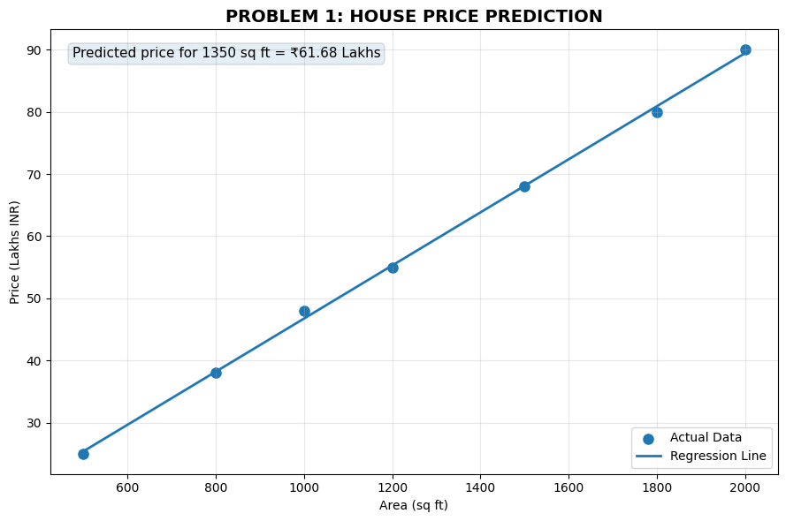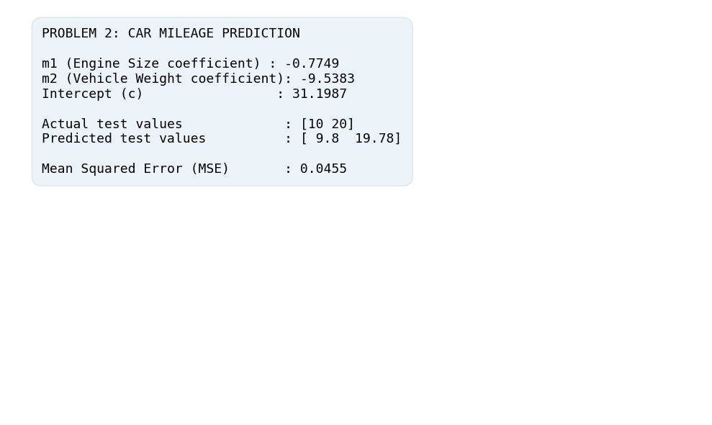
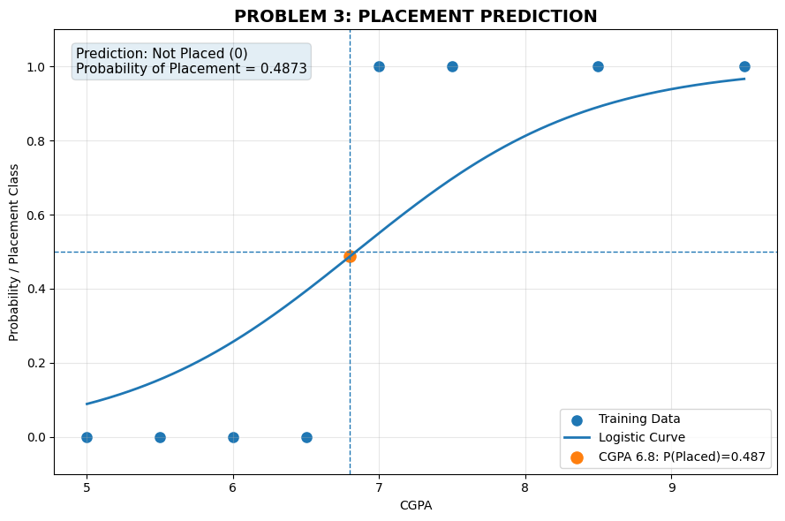
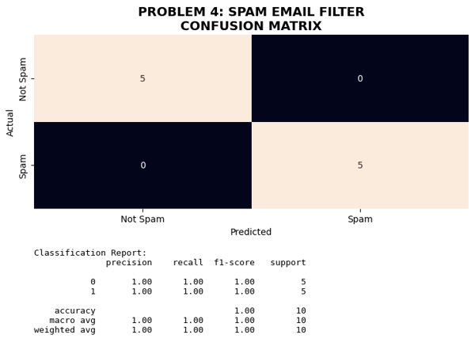

VIVA QUESTIONS
Q1. What is the cost function of Linear Regression?
The cost function of Linear Regression is Mean Squared Error (MSE). It measures the average squared difference between the actual and predicted values. The goal is to minimize this error.
Q2. Why is Logistic Regression a classification algorithm despite its name?
Logistic Regression is used for classification because it predicts the probability of an input belonging to a particular class. The probability is converted into a class such as 0 or 1 using a threshold, usually 0.5.
Q3. What is the sigmoid function and why is it used?
The sigmoid function converts any real-valued input into a value between 0 and 1. It is used in Logistic Regression to represent the probability of belonging to a class.

Date: Faculty Signature:

WEEK 4: Support Vector Machines – Linear and Non-Linear
Experiment No: 5 Date: / /

AIM
To implement Support Vector Machines: to visualise the hyperplane, margin and support vectors of a linear SVM, and to apply linear SVM to the Iris dataset (a non-linear kernel SVM is also studied).

SOFTWARE REQUIRED
Python 3.x, Jupyter Notebook / Google Colab / Anaconda, NumPy, pandas, scikit-learn, matplotlib, seaborn.

ALGORITHM
- Load or create the dataset and split it into training and testing sets.
- Fit a Linear SVM (kernel = 'linear') on the training data.
- Extract the weight vector, bias and support vectors from the trained model.
- Plot the data points, the separating hyperplane, the two margin boundaries and highlight the support vectors.
- Predict on the test data and evaluate using accuracy, confusion matrix and classification report.
- Visualise the decision regions.
- Non-linear SVM: repeat with an RBF kernel on non-linearly separable data and compare.

FORMULAS
Hyperplane:

Margin:

Optimisation problem:
𝑤 · 𝑥 + 𝑏 = 0

𝑀𝑎𝑟𝑔𝑖𝑛 = ²
‖𝑤‖

1 2

𝑚𝑖𝑛 2 ‖𝑤‖ 𝑠𝑢𝑏𝑗𝑒𝑐𝑡 𝑡𝑜𝑦 (𝑤 ·𝑥 + 𝑏) ≥ 1

RBF kernel:
𝑖 𝑖

2

−γ‖𝑥 − 𝑧‖
𝐾(𝑥, 𝑧) = 𝑒

PROGRAM
Program 1: Visualizing the Hyperplane, Margin and Support Vectors
Objective: Fit a Linear SVM on a simple 2D dataset and plot the hyperplane, the two margin boundaries and the support vectors.
import numpy as np
import matplotlib.pyplot as plt
from sklearn.svm import SVC
X = np.array([
[1, 2], [2, 3], [2, 1], [3, 2],
[6, 7], [7, 8], [8, 6], [9, 7]
])
y = np.array([-1, -1, -1, -1, 1, 1, 1, 1])
model = SVC(kernel='linear', C=1)
model.fit(X, y)
w = model.coef_[0]
b = model.intercept_[0]
x = np.linspace(0, 10, 300)
hyperplane = -(w[0] * x + b) / w[1]
margin1 = -(w[0] * x + b - 1) / w[1]
margin2 = -(w[0] * x + b + 1) / w[1]
plt.scatter(X[y == -1, 0], X[y == -1, 1],
label='Class -1')
plt.scatter(X[y == 1, 0], X[y == 1, 1],
label='Class +1')
plt.plot(x, hyperplane, label='Hyperplane')
plt.plot(x, margin1, '--', label='Margin')
plt.plot(x, margin2, '--')
plt.scatter(
model.support_vectors_[:, 0],
model.support_vectors_[:, 1],
s=150,
facecolors='none',
edgecolors='black',
linewidths=2,
label='Support Vectors'
)
plt.xlabel('Feature 1')
plt.ylabel('Feature 2')
plt.title('Linear SVM: Hyperplane, Margins and Support Vectors')
plt.legend()
plt.grid(True)
plt.show()
print("Weight vector:", w)
print("Intercept:", b)
print("Number of Support Vectors:", len(model.support_vectors_))

Program 2: Linear SVM on the Iris Dataset
Objective: Apply Linear SVM to a real dataset, evaluate it with standard metrics and visualize the decision regions.
import numpy as np
import matplotlib.pyplot as plt
from sklearn.datasets import load_iris
from sklearn.model_selection import train_test_split
from sklearn.svm import SVC
from sklearn.preprocessing import StandardScaler
from sklearn.pipeline import make_pipeline
from sklearn.metrics import accuracy_score, classification_report, confusion_matrix

iris = load_iris()
X = iris.data[:, :2]
y = iris.target

X_train, X_test, y_train, y_test = train_test_split(X, y, test_size=0.2, random_state=42, stratify=y)

model = make_pipeline(StandardScaler(), SVC(kernel='linear', C=1))
model.fit(X_train, y_train)

y_pred = model.predict(X_test)

accuracy = accuracy_score(y_test, y_pred)
print("Test Accuracy:", accuracy)
print("\nClassification Report:")
print(classification_report(y_test, y_pred, target_names=iris.target_names))
print("Confusion Matrix:")
print(confusion_matrix(y_test, y_pred))

x_min, x_max = X[:, 0].min() - 0.5, X[:, 0].max() + 0.5
y_min, y_max = X[:, 1].min() - 0.5, X[:, 1].max() + 0.5

xx, yy = np.meshgrid(np.linspace(x_min, x_max, 400), np.linspace(y_min, y_max, 400))

Z = model.predict(np.c_[xx.ravel(), yy.ravel()])
Z = Z.reshape(xx.shape)

plt.figure(figsize=(8, 6))
plt.contourf(xx, yy, Z, alpha=0.25)
plt.scatter(X[y == 0, 0], X[y == 0, 1], label='Setosa')
plt.scatter(X[y == 1, 0], X[y == 1, 1], label='Versicolor')
plt.scatter(X[y == 2, 0], X[y == 2, 1], label='Virginica')
plt.xlabel('Sepal Length (cm)')
plt.ylabel('Sepal Width (cm)')
plt.title('Linear SVM - Iris Dataset Decision Regions')
plt.legend()
plt.grid(True)
plt.show()

OUTPUT
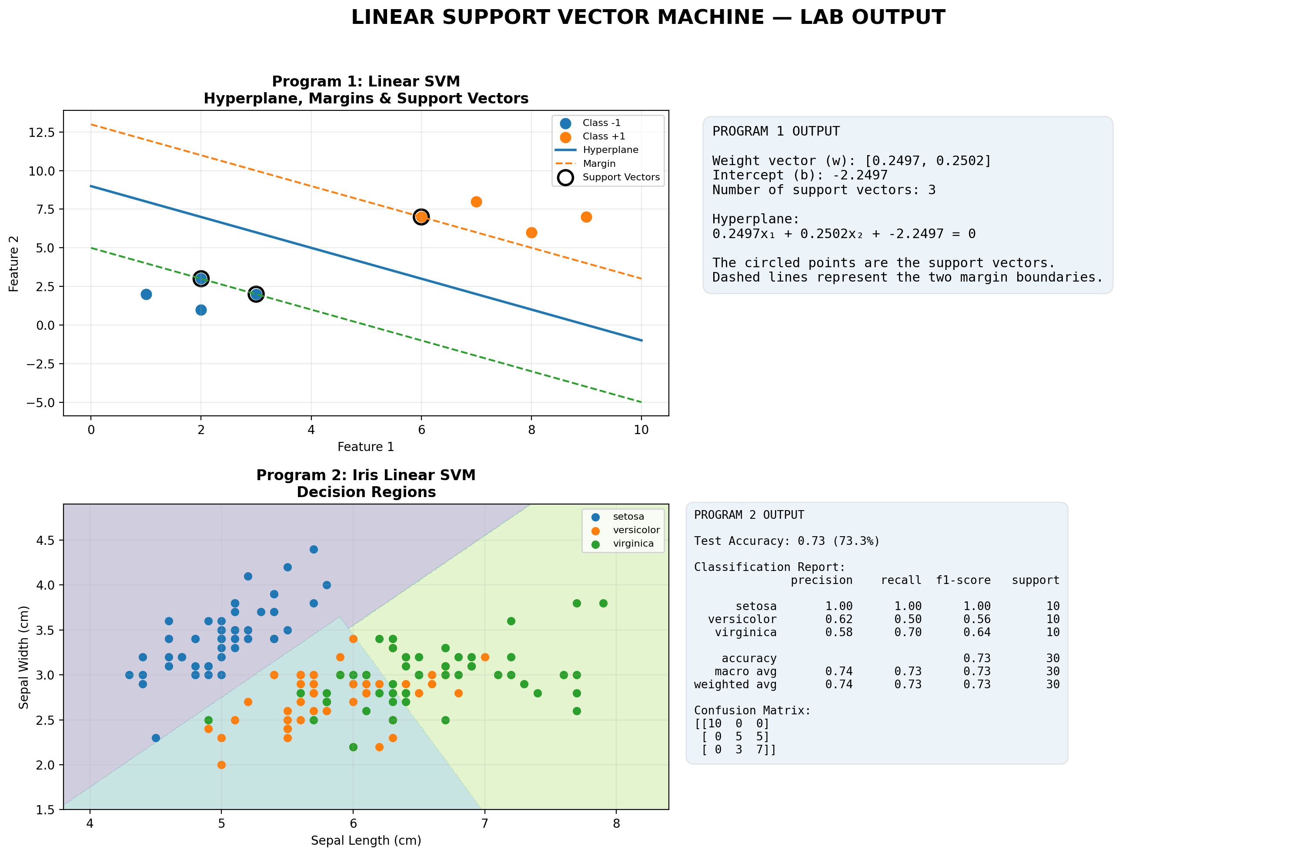

VIVA QUESTIONS
Q1. What are support vectors?
Support vectors are the data points closest to the decision boundary (hyperplane). They determine the position and orientation of the hyperplane and the margin in an SVM.
Q2. What is the kernel trick?
The kernel trick allows SVM to separate data that is not linearly separable by implicitly mapping the data into a higher-dimensional space, without explicitly performing that transformation.
Examples of kernels include Linear, Polynomial, RBF, and Sigmoid.
Q3. What is the role of the parameters C and gamma?
- C: Controls the penalty for misclassification.
  - Large C → tries to classify training data correctly, which can lead to overfitting.
  - Small C → allows more misclassification and creates a wider margin.
- Gamma: Controls how far the influence of an individual training point extends in an RBF kernel.
  - Large gamma → very narrow influence, potentially causing overfitting.
  - Small gamma → wider influence, potentially causing underfitting.

Date: Faculty Signature:

WEEK 5: Unsupervised k-Means Clustering Algorithm
Experiment No: 6 Date: / /

AIM
To implement the k-Means clustering algorithm and determine the optimal number of clusters using the elbow method.

SOFTWARE REQUIRED
Python 3.x, Jupyter Notebook / Google Colab / Anaconda, NumPy, pandas, scikit-learn, matplotlib, seaborn.

ALGORITHM
- Choose the number of clusters k and initialise k centroids randomly.
- Assign every data point to the nearest centroid.
- Recompute each centroid as the mean of the points assigned to it.
- Repeat the assignment and update steps until the centroids no longer change.
- Plot the clusters and centroids.
- Use the elbow method (inertia versus k) to choose k.

FORMULAS
Objective (within-cluster sum of squares):

𝐾
𝐽 = ∑
2
∑ ‖𝑥 − µ ‖
𝑘

Centroid update:
𝑘=1 𝑥 ∈𝐶
𝑘

1
=
µ
𝑘 |𝐶 |
∑ 𝑥

𝑘 𝑥 ∈𝐶
𝑘

PROGRAM
- Means clustering and elbow method
import numpy as np
import matplotlib.pyplot as plt
from sklearn.cluster import KMeans

X = np.array([[1,2],[2,1],[2,3],[3,2],[3,3],[8,8],[9,7],[8,9],[9,9],[10,8],[5,14],[6,13],[5,15],[7,14],[6,15]])

inertia = []
for k in range(1,8):
model = KMeans(n_clusters=k, random_state=42, n_init=10)
model.fit(X)
inertia.append(model.inertia_)

kmeans = KMeans(n_clusters=3, random_state=42, n_init=10)
labels = kmeans.fit_predict(X)
centers = kmeans.cluster_centers_

plt.figure(figsize=(7,5))
plt.plot(range(1,8), inertia, marker='o')
plt.xlabel('Number of Clusters (K)')
plt.ylabel('Inertia')
plt.title('Elbow Method')
plt.grid(True)
plt.show()

plt.figure(figsize=(7,5))
for i in range(3):
plt.scatter(X[labels == i, 0], X[labels == i, 1], label=f'Cluster {i+1}')
plt.scatter(centers[:,0], centers[:,1], s=180, marker='X', label='Centroids')
plt.xlabel('Feature 1')
plt.ylabel('Feature 2')
plt.title('K-Means Clustering (K=3)')
plt.legend()
plt.grid(True)
plt.show()

print("Elbow Method Inertia Values:")
for k, value in enumerate(inertia, 1):
print(f"K = {k}: {value:.2f}")

print("\nOptimal K = 3")
print("\nCluster Centers:")
print(centers)

OUTPUT
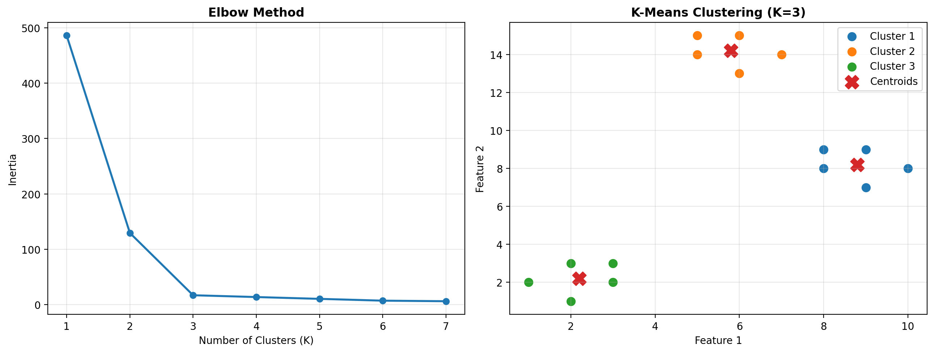

VIVA QUESTIONS
Q1. What objective function does k-Means minimise?
k-Means minimizes the Within-Cluster Sum of Squares (WCSS), also called inertia. It minimizes the sum of squared distances between each data point and its assigned cluster centroid.
Q2. What are the limitations of k-Means?
- The number of clusters K must be specified beforehand.
- Sensitive to outliers and noise.
- Sensitive to initial centroid selection.
- Works best with roughly spherical and similarly sized clusters.
- Requires numerical data and is affected by feature scaling.
Q3. What is the elbow method?
The elbow method is used to find a suitable value of K. We plot WCSS against the number of clusters and choose the point where the decrease in WCSS becomes less significant—the “elbow” point.

Date: Faculty Signature:

WEEK 6: EM Algorithm vs k-Means Clustering
Experiment No: 7 Date: / /

AIM
To apply the EM algorithm (Gaussian Mixture Model) to cluster data stored in a .CSV file, cluster the same data using k-Means, and compare the quality of the two clusterings.

SOFTWARE REQUIRED
Python 3.x, Jupyter Notebook / Google Colab / Anaconda, NumPy, pandas, scikit-learn, matplotlib, seaborn.

ALGORITHM
  - Read the data from the .CSV file using pandas.
  - EM: initialise the means, covariances and mixing coefficients of k Gaussian components.
  - E-step: compute the responsibility of each component for every data point.
  - M-step: re-estimate the means, covariances and mixing coefficients using the responsibilities.
  - Repeat the E and M steps until the log-likelihood converges.
  - Cluster the same data using k-Means.
  - Compare both results using Adjusted Rand Index and Silhouette score and comment on the quality of clustering.

FORMULAS
E-step (responsibility):

γ
𝑖𝑘
π 𝑁(𝑥 |µ ,Σ )
𝑘 𝑖 𝑘 𝑘
=
𝐾
∑ π 𝑁(𝑥 |µ ,Σ )

M-step (mean and mixing coefficient):
𝑗
𝑗=1

𝑁
𝑖 𝑗 𝑗

∑ γ 𝑥 𝑁

𝑖𝑘 𝑖

µ = 𝑖=1 π
= 𝑘

𝑘 ^{𝑁} 𝑘 𝑁
∑ γ
𝑖𝑘
𝑖=1

PROGRAM
EM (Gaussian Mixture) and k-Means comparison
import numpy as np
import matplotlib.pyplot as plt
from sklearn.cluster import KMeans
from sklearn.mixture import GaussianMixture
from sklearn.metrics import adjusted_rand_score

X = np.array([[1,2],[2,1],[2,3],[3,2],[3,3],[8,8],[9,7],[8,9],[9,9],[10,8],[5,14],[6,13],[5,15],[7,14],[6,15]])

kmeans = KMeans(n_clusters=3, random_state=42, n_init=10)
k_labels = kmeans.fit_predict(X)

em = GaussianMixture(n_components=3, random_state=42)
em_labels = em.fit_predict(X)

print("K-Means Cluster Centers:")
print(kmeans.cluster_centers_)

print("\nEM Gaussian Means:")
print(em.means_)

print("\nK-Means Inertia:", round(kmeans.inertia_, 2))
print("K-Means vs EM ARI:", round(adjusted_rand_score(k_labels, em_labels), 2))

plt.figure(figsize=(12,5))

plt.subplot(1,2,1)
for i in range(3):
plt.scatter(X[k_labels == i, 0], X[k_labels == i, 1], label=f'Cluster {i+1}')
plt.scatter(kmeans.cluster_centers_[:,0], kmeans.cluster_centers_[:,1], s=180, marker='X', label='Centroids')
plt.xlabel('Feature 1')
plt.ylabel('Feature 2')
plt.title('K-Means Clustering')
plt.legend()
plt.grid(True)

plt.subplot(1,2,2)
for i in range(3):
plt.scatter(X[em_labels == i, 0], X[em_labels == i, 1], label=f'Cluster {i+1}')
plt.scatter(em.means_[:,0], em.means_[:,1], s=180, marker='X', label='Gaussian Means')
plt.xlabel('Feature 1')
plt.ylabel('Feature 2')
plt.title('EM (Gaussian Mixture) Clustering')
plt.legend()
plt.grid(True)
plt.tight_layout()
plt.show()

OUTPUT
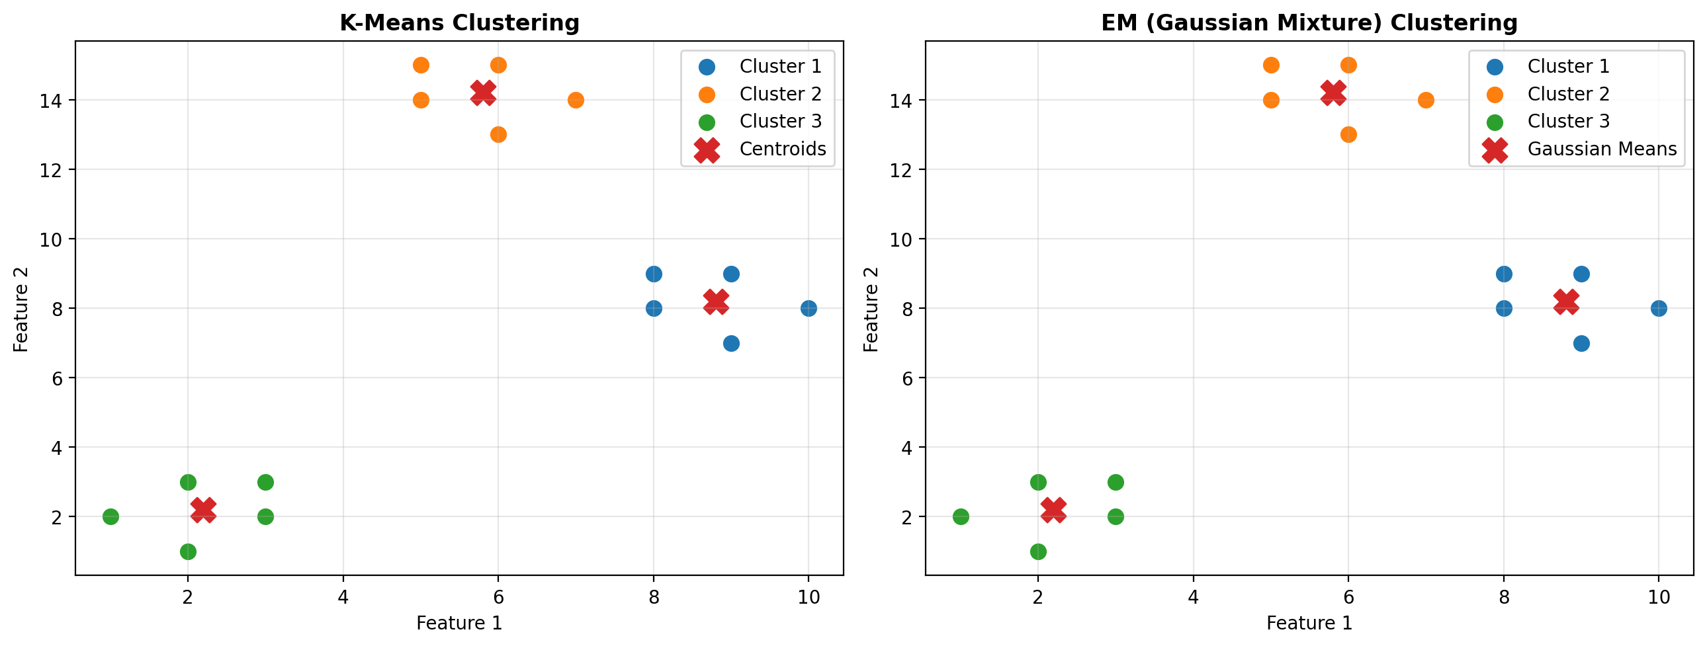

VIVA QUESTIONS
Q1. What are the E-step and M-step?
- E-step (Expectation): Calculates the probability that each data point belongs to each cluster.
- M-step (Maximization): Updates the model parameters (mean, covariance, and cluster probability) using those calculated probabilities.
- These steps are repeated until the model converges.
Q2. How does EM differ from k-Means (soft vs hard assignment)?
- k-Means – Hard assignment: Each data point belongs to only one cluster.
- EM – Soft assignment: Each data point has a probability of belonging to every cluster.
Example: EM may assign a point as 70% Cluster 1 and 30% Cluster 2, while k-Means assigns it entirely to one cluster.
Q3. Which method handles elliptical clusters better and why?
EM (Gaussian Mixture Model) handles elliptical clusters better because it models each cluster using a covariance matrix, allowing clusters to have different shapes, sizes, and orientations.

Date: Faculty Signature:

WEEK 7: Model Training: Holdout, K-Fold Cross Validation and Bootstrap Sampling
Experiment No: 8 Date: / /

AIM
To train and validate a model using the Holdout method, K-Fold cross validation and Bootstrap sampling.

SOFTWARE REQUIRED
Python 3.x, Jupyter Notebook / Google Colab / Anaconda, NumPy, pandas, scikit-learn, matplotlib, seaborn.

ALGORITHM
- Holdout: randomly split the data into training (e.g. 70%) and testing (30%) sets; train and test once.
- K-Fold: divide the data into K equal folds; use each fold once as the test set while training on the remaining folds; average the K scores.
- Bootstrap: draw n samples with replacement to form the training set; the samples not drawn (out-of-bag) form the test set; repeat many times and average.
- Compare the accuracies obtained from the three methods.

FORMULAS
K-Fold cross-validation score:
𝐾
𝐶𝑉 = ¹ ∑ 𝐴𝑐𝑐𝑢𝑟𝑎𝑐𝑦
𝐾 𝑘
𝑘=1
Probability that a sample is not picked in a bootstrap sample:
𝑃 = (1 − ¹ )𝑛≈ 0. 368
𝑛

PROGRAM
Holdout, K-Fold and Bootstrap
import numpy as np
import matplotlib.pyplot as plt
from sklearn.datasets import load_iris
from sklearn.ensemble import RandomForestClassifier
from sklearn.model_selection import train_test_split, KFold, cross_val_score
from sklearn.metrics import accuracy_score
iris = load_iris()
X = iris.data
y = iris.target
model = RandomForestClassifier(n_estimators=100, random_state=42)
X_train, X_test, y_train, y_test = train_test_split(X, y, test_size=0.2, random_state=42, stratify=y)
model.fit(X_train, y_train)
holdout_accuracy = accuracy_score(y_test, model.predict(X_test))
kf = KFold(n_splits=5, shuffle=True, random_state=42)
kfold_scores = cross_val_score(model, X, y, cv=kf, scoring='accuracy')
bootstrap_scores = []
rng = np.random.RandomState(42)

for i in range(10):
indices = rng.choice(len(X), size=len(X), replace=True)
oob = np.setdiff1d(np.arange(len(X)), np.unique(indices))
model.fit(X[indices], y[indices])
if len(oob) > 0:
bootstrap_scores.append(accuracy_score(y[oob], model.predict(X[oob])))

bootstrap_mean = np.mean(bootstrap_scores)

print("Holdout Method Accuracy:", round(holdout_accuracy, 4))
print("\nK-Fold Cross Validation Scores:")
print(np.round(kfold_scores, 4))
print("K-Fold Mean Accuracy:", round(kfold_scores.mean(), 4))

print("\nBootstrap Scores:")
print(np.round(bootstrap_scores, 4))
print("Bootstrap Mean Accuracy:", round(bootstrap_mean, 4))

methods = ['Holdout', 'K-Fold', 'Bootstrap']
scores = [holdout_accuracy, kfold_scores.mean(), bootstrap_mean]
plt.figure(figsize=(8, 5))
plt.bar(methods, scores)
plt.ylim(0, 1.1)
plt.ylabel('Accuracy')
plt.title('Comparison of Holdout, K-Fold and Bootstrap')
plt.grid(axis='y', alpha=0.3)
plt.tight_layout()
plt.show()

OUTPUT
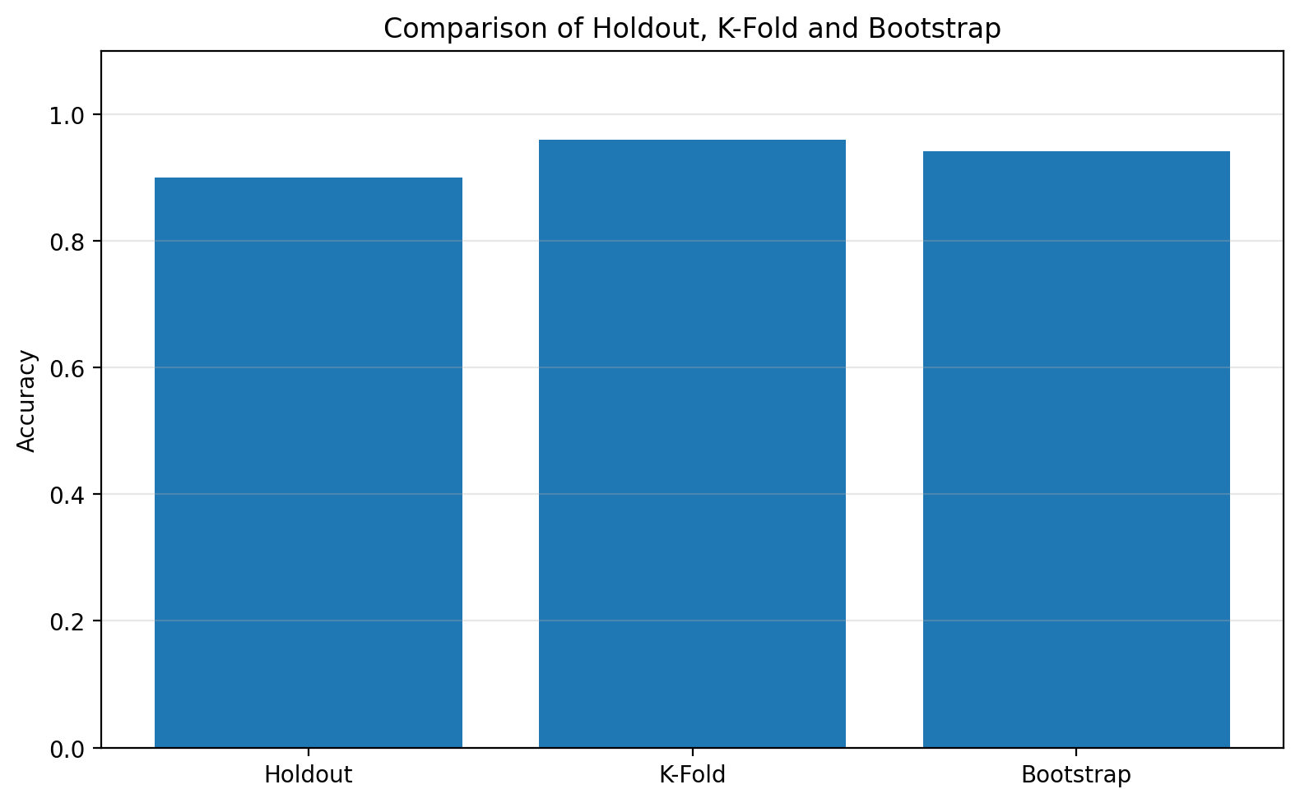

VIVA QUESTIONS
Q1. What is the difference between holdout and k-fold validation?
- Holdout: Splits the dataset once into training and testing sets.
- K-Fold: Divides the dataset into K parts and trains/tests the model K times, using a different part for testing each time.
- K-Fold generally gives a more reliable performance estimate than a single holdout split.
Q2. What is an out-of-bag (OOB) sample?
An out-of-bag sample is a data point that is not selected in a particular bootstrap sample used to train a model in methods like Random Forest. It can be used to evaluate the model without needing a separate validation set.
Q3. What is stratified k-fold and when is it used?
Stratified k-fold maintains approximately the same class proportion in every fold as in the original dataset.
It is mainly used for classification problems, especially when the classes are imbalanced.

Date: Faculty Signature:

WEEK 8: Evaluating Model Performance (Lower Back Pain Symptoms Dataset)
Experiment No: 9 Date: / /

AIM
To evaluate the performance of supervised classification, supervised regression and unsupervised clustering models on the Lower Back Pain Symptoms dataset (310 observations, 13 attributes), and to measure cluster quality using purity and silhouette width.

SOFTWARE REQUIRED
Python 3.x, Jupyter Notebook / Google Colab / Anaconda, NumPy, pandas, scikit-learn, matplotlib, seaborn.

ALGORITHM
- Load the dataset (Kaggle: sammy123/lower-back-pain-symptoms-dataset) and remove the unnamed column.
- Classification: encode Class_att (Abnormal / Normal), train a classifier and compute accuracy, precision, recall, F1-score, confusion matrix and ROC-AUC.
- Regression: predict one numeric attribute (Col1) from the others and compute MAE, MSE, RMSE and R².
- Clustering: standardise the features, apply k-Means with k = 2 and compute purity and silhouette width against the true classes.

FORMULAS
Accuracy:

Precision:

Recall:

F1-score:

Mean Absolute Error:
𝑇𝑃 + 𝑇𝑁
𝑇𝑃 + 𝑇𝑁 + 𝐹𝑃 + 𝐹𝑁
𝐴𝑐𝑐𝑢𝑟𝑎𝑐𝑦 =

𝑃𝑟𝑒𝑐𝑖𝑠𝑖𝑜𝑛 = ^{𝑇𝑃}
𝑇𝑃 + 𝐹𝑃

𝑅𝑒𝑐𝑎𝑙𝑙 = ^{𝑇𝑃}
𝑇𝑃 + 𝐹𝑁

2 × 𝑃𝑟𝑒𝑐𝑖𝑠𝑖𝑜𝑛 × 𝑅𝑒𝑐𝑎𝑙𝑙
𝐹1 =
𝑃𝑟𝑒𝑐𝑖𝑠𝑖𝑜𝑛 + 𝑅𝑒𝑐𝑎𝑙𝑙

𝑛

𝑀𝐴𝐸 = ¹ ∑ |𝑦 − ŷ |

Root Mean Squared Error:
𝑛 𝑖 𝑖
𝑖=1

R² score:
𝑅𝑀𝑆𝐸 =

𝑆𝑆
𝑀𝑆𝐸

Purity:
𝑅² = 1 − 𝑟𝑒𝑠
𝑡𝑜𝑡
𝑆𝑆

𝑃𝑢𝑟𝑖𝑡𝑦 = ¹ ∑ 𝑚𝑎𝑥 |ω

∩ 𝑐 |

𝑁 𝑗 𝑘 𝑗
𝑘

Silhouette width:

PROGRAM

𝑏(𝑖) − 𝑎(𝑖)
𝑚𝑎𝑥{𝑎(𝑖), 𝑏(𝑖)}
𝑠(𝑖) =

Classification, Regression and Clustering evaluation
import matplotlib.pyplot as plt
from sklearn.datasets import load_iris,load_diabetes
from sklearn.model_selection import train_test_split
from sklearn.linear_model import LogisticRegression,LinearRegression
from sklearn.cluster import KMeans
from sklearn.metrics import *
iris=load_iris()
X,y=iris.data,(iris.target==0).astype(int)
Xtr,Xte,ytr,yte=train_test_split(X,y,test_size=.2,random_state=42,stratify=y)
m=LogisticRegression(max_iter=200).fit(Xtr,ytr)
yp=m.predict(Xte)

print("CLASSIFICATION")
print("Accuracy:",accuracy_score(yte,yp))
print("Precision:",precision_score(yte,yp))
print("Recall:",recall_score(yte,yp))
print("F1 Score:",f1_score(yte,yp))
data=load_diabetes()
Xtr,Xte,ytr,yte=train_test_split(data.data,data.target,test_size=.2,random_state=42)
m=LinearRegression().fit(Xtr,ytr)
yr=m.predict(Xte)

print("\nREGRESSION")
print("MSE:",mean_squared_error(yte,yr))
print("MAE:",mean_absolute_error(yte,yr))
print("R2 Score:",r2_score(yte,yr))
X=iris.data[:,:2]
k=KMeans(n_clusters=3,random_state=42,n_init=10)
labels=k.fit_predict(X)
print("\nCLUSTERING")
print("Silhouette Score:",silhouette_score(X,labels))

plt.figure(figsize=(12,4))
plt.subplot(1,3,1)
plt.bar(["Accuracy","Precision","Recall","F1"],[accuracy_score(yte,yp),precision_score(yte,yp),recall_score(yte,yp),f1_score(yte,yp)])
plt.title("Classification")
plt.subplot(1,3,2)
plt.scatter(yte,yr)
plt.xlabel("Actual")
plt.ylabel("Predicted")
plt.title("Regression")
plt.subplot(1,3,3)
plt.scatter(X[:,0],X[:,1],c=labels)
plt.scatter(k.cluster_centers_[:,0],k.cluster_centers_[:,1],marker="X",s=150)
plt.title("Clustering")
plt.tight_layout()
plt.show()

OUTPUT
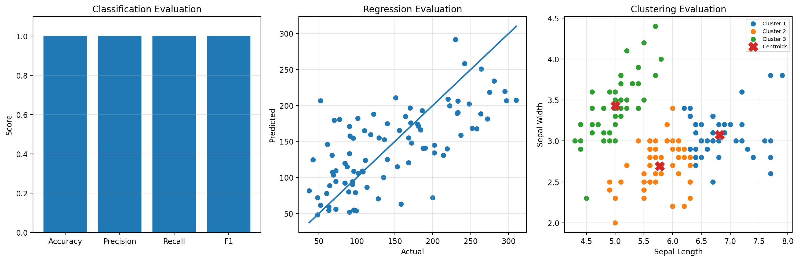

VIVA QUESTIONS
Q1. Why is accuracy alone not sufficient to evaluate a classifier?
Accuracy can be misleading when the classes are imbalanced. A model may have high accuracy while performing poorly on the minority class. Therefore, metrics like precision, recall, and F1-score are also used.
Q2. Explain precision, recall and F1-score.
- Precision: Out of all samples predicted as positive, how many are actually positive.
- Recall: Out of all actual positive samples, how many are correctly identified.
- F1-score: Harmonic mean of precision and recall. It balances both metrics.
F1 = 2 × (Precision × Recall) / (Precision + Recall)
Q3. What does a silhouette value close to 1 or −1 indicate?
- Close to +1: Data points are well matched to their own cluster and far from other clusters → good clustering.
- Close to 0: Clusters overlap or are poorly separated.
- Close to −1: Data points may be assigned to the wrong cluster.

Date: Faculty Signature:

WEEK 9: Random Forest Learning Algorithm
Experiment No: 10 Date: / /

AIM
To implement the Random Forest ensemble learning algorithm and analyse feature importance.

SOFTWARE REQUIRED
Python 3.x, Jupyter Notebook / Google Colab / Anaconda, NumPy, pandas, scikit-learn, matplotlib, seaborn.

ALGORITHM
- Load the dataset and split it into training and testing sets.
- Create T bootstrap samples from the training data.
- Grow a decision tree on each sample, considering only a random subset of features at every split.
- Combine the predictions of all trees by majority voting.
- Evaluate the accuracy and list the most important features.

FORMULAS
Majority vote of T trees:

ŷ = 𝑚𝑜𝑑𝑒{ℎ (𝑥), ℎ (𝑥), …, ℎ (𝑥) }
1 2 𝑇

PROGRAM
Random Forest classifier

import matplotlib.pyplot as plt
from sklearn.datasets import load_iris
from sklearn.model_selection import train_test_split
from sklearn.ensemble import RandomForestClassifier
from sklearn.metrics import accuracy_score,classification_report,confusion_matrix

d=load_iris()
Xtr,Xte,ytr,yte=train_test_split(d.data,d.target,test_size=.2,random_state=42,stratify=d.target)
m=RandomForestClassifier(n_estimators=100,random_state=42).fit(Xtr,ytr)
p=m.predict(Xte)

print("Accuracy:",accuracy_score(yte,p))
print("\nClassification Report:")
print(classification_report(yte,p,target_names=d.target_names))
print("Confusion Matrix:")
print(confusion_matrix(yte,p))

plt.figure(figsize=(10,4))
plt.subplot(1,2,1)
cm=confusion_matrix(yte,p)
plt.imshow(cm)
plt.xticks(range(3),d.target_names)
plt.yticks(range(3),d.target_names)
plt.xlabel("Predicted")
plt.ylabel("Actual")
plt.title("Confusion Matrix")
for i in range(3):
for j in range(3):
plt.text(j,i,cm[i,j],ha="center",va="center")

plt.subplot(1,2,2)
plt.bar(d.feature_names,m.feature_importances_)
plt.xticks(range(4),["Sepal L","Sepal W","Petal L","Petal W"],rotation=20)
plt.ylabel("Importance")
plt.title("Feature Importance")
plt.tight_layout()
plt.show()

OUTPUT
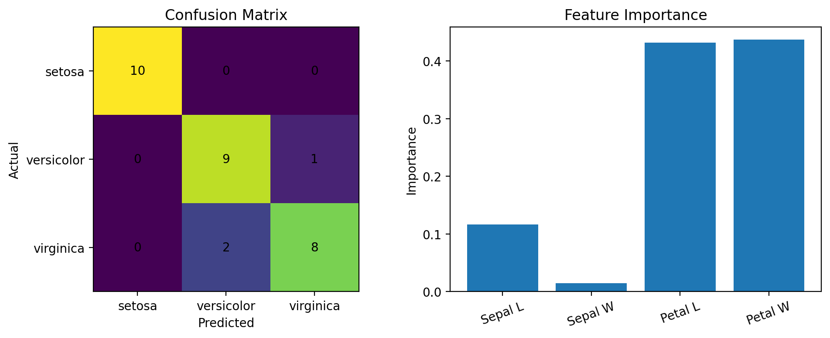

VIVA QUESTIONS
Q1. How does Random Forest reduce variance compared to a single tree?
Random Forest builds many decision trees using different bootstrap samples and random subsets of features, then combines their predictions. Averaging these trees reduces variance and overfitting compared to a single decision tree.
Q2. What is bagging?
Bagging (Bootstrap Aggregating) is an ensemble technique that:
- Creates multiple bootstrap samples from the training data.
- Trains a separate model on each sample.
- Combines their predictions, usually by majority voting for classification or averaging for regression.
Q3. What is out-of-bag error?
Out-of-bag (OOB) error is the error calculated using the training samples that were not selected in the bootstrap sample for a particular tree. It provides an estimate of model performance without requiring a separate validation set.

Date: Faculty Signature:

WEEK 10: AdaBoost and XGBoost Algorithms
Experiment No: 11 Date: / /

AIM
To implement the boosting algorithms AdaBoost and XGBoost and compare their performance.

SOFTWARE REQUIRED
Python 3.x, Jupyter Notebook / Google Colab / Anaconda, NumPy, pandas, scikit-learn, matplotlib, seaborn, xgboost.

ALGORITHM
- Initialise equal weights for all training samples.
- AdaBoost: train a weak learner (decision stump) and compute its weighted error and its weight (alpha).
- Increase the weights of misclassified samples, normalise, and repeat for T rounds.
- The final prediction is the weighted vote of all weak learners.
- XGBoost: build trees one after another, each correcting the errors of the previous ensemble using gradients of a regularised loss.
- Compare the test accuracies of both models.
- (Install XGBoost using: pip install xgboost)

FORMULAS
AdaBoost learner weight:
1 ( 1 −ε )

AdaBoost sample-weight update:
α = 𝑙𝑛 𝑡
𝑡
2
𝑡
ε

−α 𝑦 ℎ (𝑥 )

AdaBoost final classifier:
𝑤 ← 𝑤 ·𝑒
𝑖 𝑖
𝑡 𝑖 𝑡 𝑖

( 𝑇 )
𝐻(𝑥) = 𝑠𝑖𝑔𝑛
∑ α ℎ (𝑥)

XGBoost objective:
𝑛
𝑡=1

𝐾
𝑡 𝑡

𝑂𝑏𝑗 = ∑ 𝑙(𝑦 , ŷ ) + ∑ Ω(𝑓 )𝑤ℎ𝑒𝑟𝑒 Ω(𝑓) = γ𝑇 + ¹ 2

𝑖=1
𝑖 𝑖
𝑘
𝑘=1
2 λ‖𝑤‖

PROGRAM
- AdaBoost
import matplotlib.pyplot as plt
from sklearn.datasets import load_iris
from sklearn.model_selection import train_test_split
from sklearn.ensemble import AdaBoostClassifier
from sklearn.tree import DecisionTreeClassifier
from sklearn.metrics import accuracy_score,confusion_matrix

d=load_iris()
Xtr,Xte,ytr,yte=train_test_split(d.data,d.target,test_size=.2,random_state=42,stratify=d.target)

m=AdaBoostClassifier(estimator=DecisionTreeClassifier(max_depth=1),n_estimators=50,random
_state=42)
m.fit(Xtr,ytr)
p=m.predict(Xte)

print("AdaBoost Accuracy:",accuracy_score(yte,p))
print("Confusion Matrix:")
print(confusion_matrix(yte,p))

- XGBoost
from sklearn.datasets import load_iris
from sklearn.model_selection import train_test_split
from xgboost import XGBClassifier
from sklearn.metrics import accuracy_score,confusion_matrix

d=load_iris()
Xtr,Xte,ytr,yte=train_test_split(d.data,d.target,test_size=.2,random_state=42,stratify=d.target)

m=XGBClassifier(n_estimators=50,max_depth=3,learning_rate=.1,eval_metric='mlogloss',random_
state=42)
m.fit(Xtr,ytr)
p=m.predict(Xte)

print("XGBoost Accuracy:",accuracy_score(yte,p))
print("Confusion Matrix:")
print(confusion_matrix(yte,p))

OUTPUT
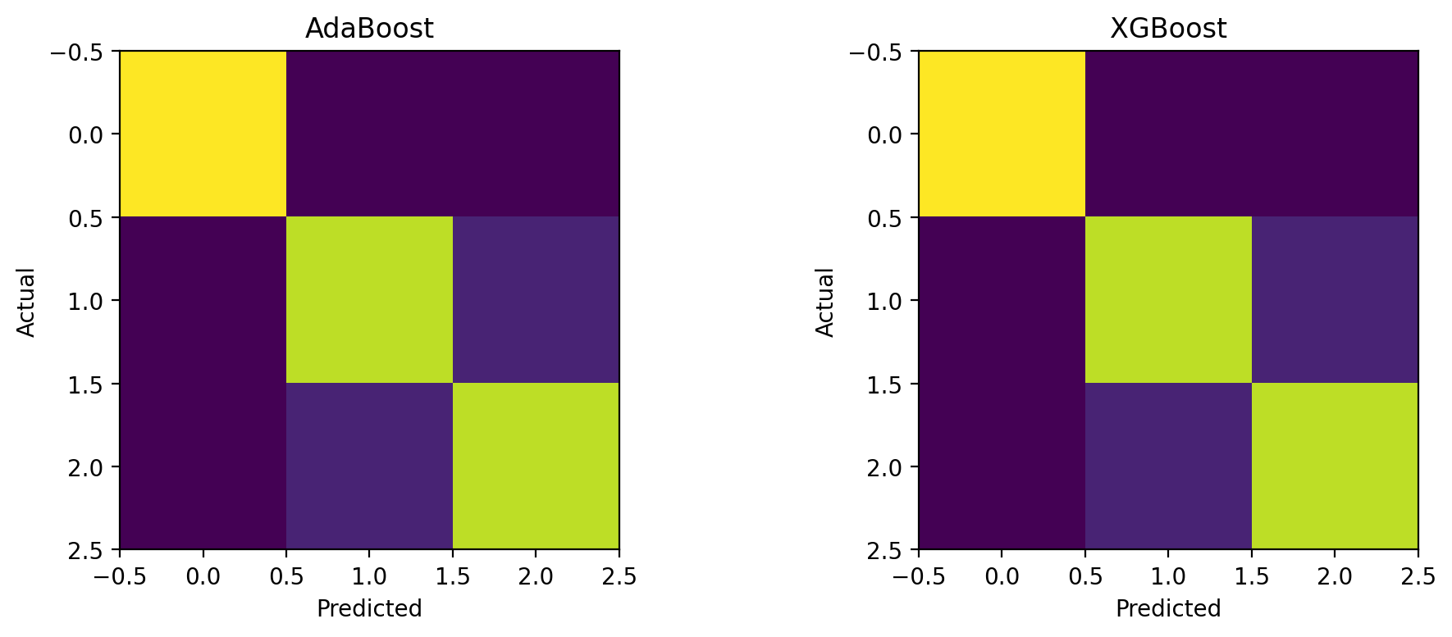

VIVA QUESTIONS
Q1. Differentiate bagging and boosting.
- Bagging: Trains multiple models independently and in parallel and combines their predictions. It mainly reduces variance.
- Boosting: Trains models sequentially, where each new model focuses on errors made by previous models. It mainly reduces bias.
Q2. How does AdaBoost update the sample weights?
AdaBoost increases the weights of misclassified samples and decreases the weights of correctly classified samples. Thus, the next weak learner focuses more on difficult examples.
Q3. What regularisation does XGBoost provide?
XGBoost provides L1 and L2 regularisation:
- L1 (Lasso): Helps reduce unnecessary features and model complexity.
- L2 (Ridge): Penalizes large leaf weights and helps prevent overfitting.
It also controls complexity using parameters such as max_depth, min_child_weight, and gamma.

Date: Faculty Signature:

WEEK 11: Single Layer Perceptron and Multilayer Perceptron
Experiment No: 12 Date: / /

AIM
To implement a Single Layer Perceptron (SLP) that classifies the logical AND gate, and a Multi-Layer Perceptron (MLP) using NumPy that learns the XOR gate.

SOFTWARE REQUIRED
Python 3.x, Jupyter Notebook / Google Colab / Anaconda, NumPy, pandas, scikit-learn, matplotlib, seaborn.

ALGORITHM
  - SLP: initialise the weights and bias with small random values.
  - SLP: for each training sample compute the weighted sum (net input).
  - SLP: apply the step activation function: output = 1 if net ≥ 0, else 0.
  - SLP: compute the error = target − output.
  - SLP: update the weights and bias using the learning rate η.
  - SLP: repeat for all samples over multiple epochs until the total error becomes zero (convergence) or the maximum number of epochs is reached; then test on all input combinations.
  - MLP: initialise the weights of the input–hidden and hidden–output layers.
  - MLP: forward propagation – calculate the hidden layer and output layer activations.
  - MLP: backpropagation – compute the error, propagate it backwards and update the weights to reduce the error.
  - MLP: repeat for many epochs and display the predicted outputs for the XOR gate.

FORMULAS
SLP net input:

𝑛𝑒𝑡 =
𝑛
∑ 𝑤 𝑥
+ 𝑏

SLP step activation:
𝑖=1
𝑖 𝑖

𝑜𝑢𝑡𝑝𝑢𝑡 = 1 𝑖𝑓 𝑛𝑒𝑡 ≥ 0, 𝑜𝑡ℎ𝑒𝑟𝑤𝑖𝑠𝑒 0
SLP weight and bias update:
𝑤 ← 𝑤 + η (𝑡 − 𝑦)𝑥 𝑏 ← 𝑏 + η (𝑡 − 𝑦)
𝑖 𝑖 𝑖
MLP forward propagation:
ℎ = σ(𝑋𝑊 + 𝑏 ) ŷ = σ(ℎ𝑊 + 𝑏 )
1 1 2 2

Sigmoid activation:

Error function:

σ(𝑧) = ¹ σ′(𝑧) = σ(𝑧) (1 − σ(𝑧))
1 +𝑒
−𝑧

𝐸 = ¹ ∑ (𝑡 − 𝑦 )
2

Weight update (gradient descent):
2 𝑘 𝑘
𝑘

𝑊 ← 𝑊 − η ^{𝜕𝐸}
𝜕𝑊

PROGRAM
- Single Layer Perceptron – AND gate
Train a single layer perceptron to correctly classify the logical AND gate.
import numpy as np
from sklearn.linear_model import Perceptron

X=np.array([[0,0],[0,1],[1,0],[1,1]])
y=np.array([0,0,0,1])

m=Perceptron(max_iter=1000,random_state=42)
m.fit(X,y)
p=m.predict(X)

print("AND GATE")
print("Input Expected Predicted")
for a,b,c in zip(X,y,p):
print(a,b,c)

- Multi-Layer Perceptron (MLP) for XOR gate using NumPy
An MLP consists of an input layer (receives input data), hidden layer(s) (learn complex patterns) and an output layer (produces the final prediction). It uses forward propagation to calculate the output and backpropagation to update the weights and reduce the error.

Input X₁ | Input X₂ | Expected Output (Y)
0 | 0 | 0
0 | 1 | 1
1 | 0 | 1
1 | 1 | 0

import numpy as np

X=np.array([[0,0],[0,1],[1,0],[1,1]],float)
y=np.array([[0],[1],[1],[0]],float)

sig=lambda z:1/(1+np.exp(-z))

W1=np.array([[5.,5.],[5.,5.]])
b1=np.array([[-2.5,-7.5]])
W2=np.array([[5.],[-5.]])
b2=np.array([[-2.5]])

for _ in range(10000):
h=sig(X@W1+b1)
o=sig(h@W2+b2)
d2=(y-o)*o*(1-o)
d1=(d2@W2.T)*h*(1-h)
W2+=.5*h.T@d2
b2+=.5*d2.sum(0,keepdims=True)
W1+=.5*X.T@d1
b1+=.5*d1.sum(0,keepdims=True)

p=(o>.5).astype(int)

print("XOR GATE")
print("Input Expected Predicted")
for a,b,c in zip(X,y.ravel(),p.ravel()):
print(a.astype(int),b,c)

OUTPUT
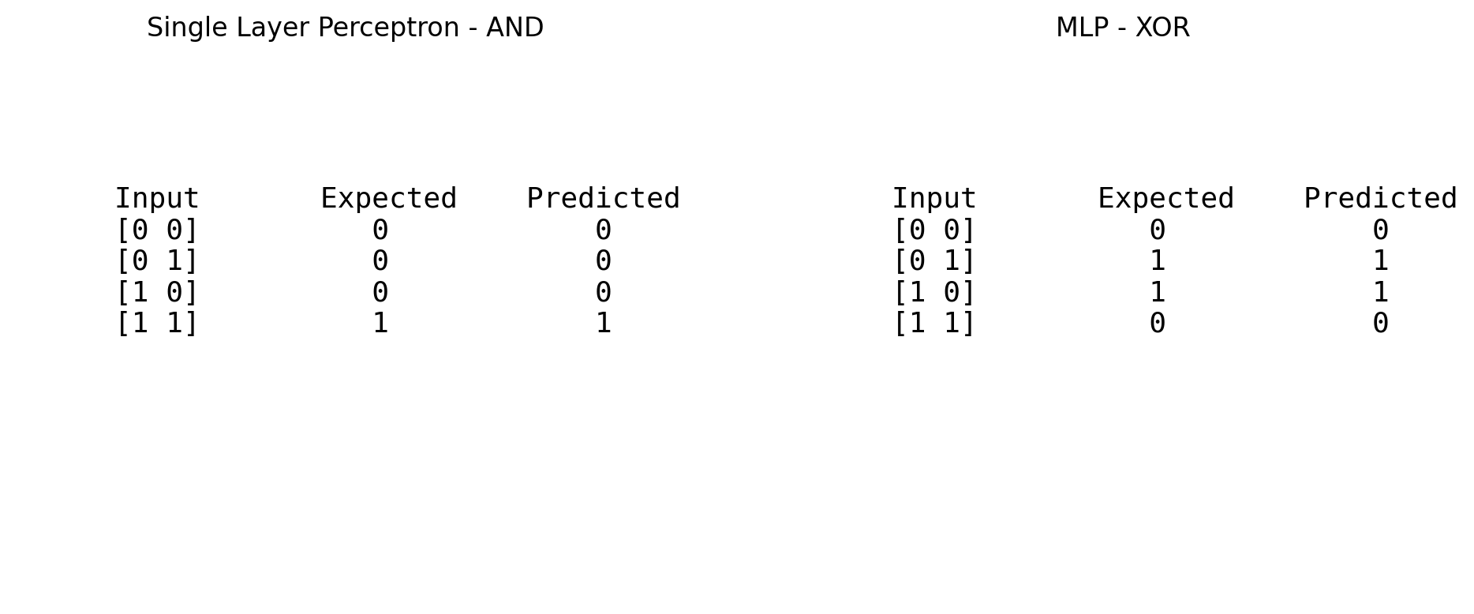

VIVA QUESTIONS
Q1. Why can a single-layer perceptron not solve the XOR problem?
A single-layer perceptron can solve only linearly separable problems. XOR is not linearly separable, so a single-layer perceptron cannot correctly classify all XOR inputs.
Q2. What is the role of the activation function?
The activation function introduces non-linearity into a neural network. This allows the network to learn complex patterns and non-linear relationships.
Examples: Sigmoid, ReLU, Tanh.
Q3. Explain the back-propagation algorithm.
Back-propagation is used to train neural networks by minimizing the error.
Steps:
- Forward propagation: Calculate the output from the input.
- Calculate error: Compare predicted output with actual output.
- Backward propagation: Calculate how much each weight contributed to the error using gradients.
- Update weights: Adjust weights using an optimization method such as gradient descent.
- Repeat these steps until the error is sufficiently reduced.
.

Date: Faculty Signature:

WEEK 12 – 13: Real-World Case Study: Amazon Food Reviews
Experiment No: 13 Date: / /

AIM
To classify Amazon fine food reviews as positive or negative using text-processing and machine learning techniques. (Alternative case study: Personalized Cancer Diagnosis.)

SOFTWARE REQUIRED
Python 3.x, Jupyter Notebook / Google Colab / Anaconda, NumPy, pandas, scikit-learn, matplotlib, seaborn.

ALGORITHM
  - Problem statement: predict the sentiment of a review from its text. Dataset: Amazon Fine Food Reviews (Kaggle, Reviews.csv).
  - Data loading: read the CSV, remove duplicates and reviews with a neutral score (Score
= 3).
  - Labelling: Score above 3 is positive (1), Score below 3 is negative (0).
  - Text pre-processing: lower-casing, removing HTML tags, punctuation and stop-words.
  - Feature extraction: TF-IDF vectorisation with unigrams and bigrams.
  - Model building: Logistic Regression and Multinomial Naïve Bayes; tune hyper-parameters if required.
  - Evaluation: accuracy, precision, recall, F1-score and confusion matrix; discuss the results.

FORMULAS
TF-IDF weight:

𝑇𝐹 − 𝐼𝐷𝐹(𝑡, 𝑑) = 𝑡𝑓(𝑡, 𝑑) × 𝑙𝑜𝑔(
𝑁
𝑑𝑓(𝑡)
)

PROGRAM
Sentiment classification of Amazon Food Reviews
import matplotlib.pyplot as plt
from sklearn.model_selection import train_test_split
from sklearn.feature_extraction.text import TfidfVectorizer
from sklearn.linear_model import LogisticRegression
from sklearn.metrics import accuracy_score,classification_report,confusion_matrix

reviews=[
"Excellent taste and great quality","Very delicious and fresh","I love this product","Amazing flavor and fast delivery","Good product and worth the price",
"Fresh tasty and wonderful food","Great quality and excellent taste","Very happy with this purchase","Delicious product and good packaging","Highly recommended and very tasty",
"Terrible taste and poor quality","Very bad product","I hate this food","Disappointing and stale","Poor flavor and not worth the money",
"Bad quality and terrible taste","Very disappointing product","Awful flavor and poor packaging","Not fresh and very bad","I would not recommend this product"]

y=[1]*10+[0]*10

Xtr,Xte,ytr,yte=train_test_split(reviews,y,test_size=.3,random_state=42,stratify=y)

v=TfidfVectorizer()
Xtr=v.fit_transform(Xtr)
Xte=v.transform(Xte)

m=LogisticRegression(max_iter=1000).fit(Xtr,ytr)
p=m.predict(Xte)

print("Amazon Food Review Sentiment Classification")
print("Accuracy:",accuracy_score(yte,p))
print("\nClassification Report:")
print(classification_report(yte,p,target_names=["Negative","Positive"]))
print("Confusion Matrix:")
print(confusion_matrix(yte,p))

cm=confusion_matrix(yte,p)
plt.imshow(cm)
plt.xticks([0,1],["Negative","Positive"])
plt.yticks([0,1],["Negative","Positive"])
plt.xlabel("Predicted")
plt.ylabel("Actual")
plt.title("Sentiment Confusion Matrix")

for i in range(2):
for j in range(2):
plt.text(j,i,cm[i,j],ha="center",va="center")

plt.show()

OUTPUT
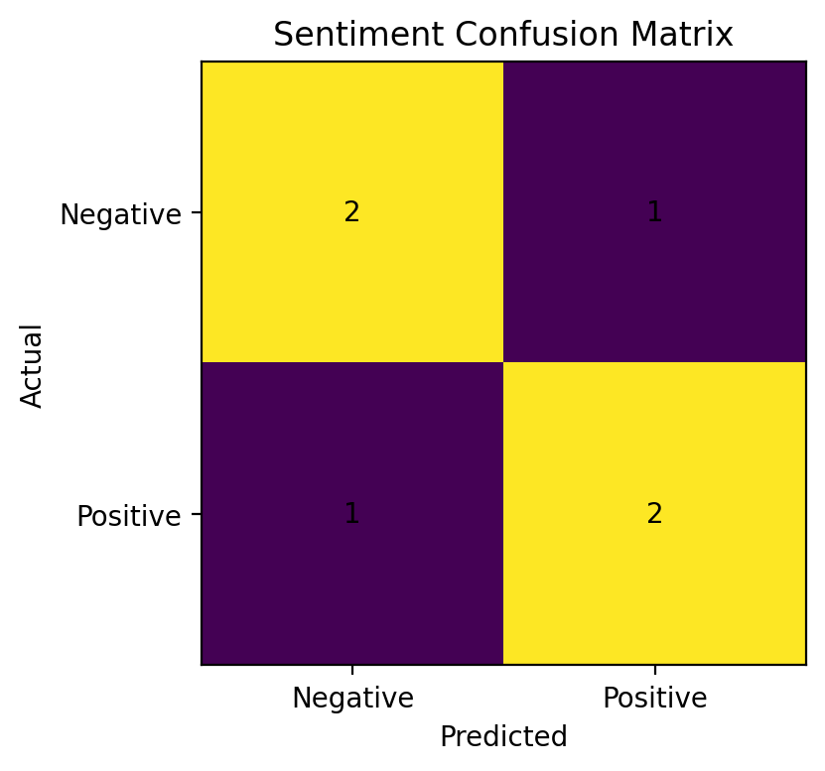

VIVA QUESTIONS
Q1. Why is TF-IDF preferred over simple word counts?
TF-IDF gives higher importance to words that are frequent in a particular document but less common across all documents. It reduces the importance of common words and often provides better features for text classification than simple word counts.
Q2. How do you handle class imbalance in review data?
- Use class weights such as class_weight='balanced'.
- Oversample the minority class.
- Undersample the majority class.
- Use suitable evaluation metrics such as precision, recall, and F1-score instead of relying only on accuracy.
Q3. What is the effect of removing stop-words?
Removing stop-words eliminates common words such as “the”, “is”, “and”, “a” that often carry little information. It can reduce the number of features and improve efficiency, but removing them may sometimes lose useful context, especially in sentiment analysis.

Date: Faculty Signature:

